Depth First Search (DFS)
Aim
To implement the Depth First Search (DFS) algorithm using Python.
Objective
- To traverse a graph using recursion.
- To visit each node exactly once.
- To understand stack/recursive traversal.
Algorithm
- Start from the source node.
- Mark it as visited.
- Print the node.
- Visit every adjacent unvisited node recursively.
- Continue until all vertices are visited.

FLOW CHART
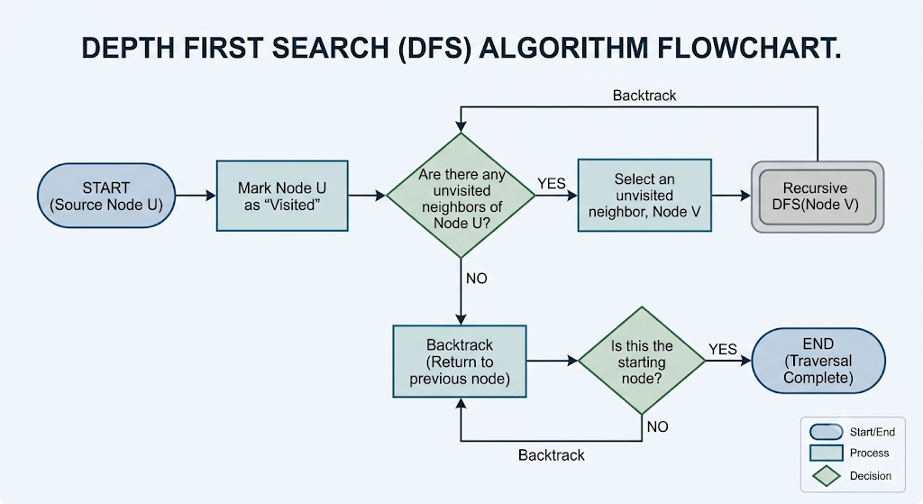

Python Code
graph = {
'A': ['B', 'C'],
'B': ['D', 'E'],
'C': ['F'],
'D': [],
'E': ['F'],
'F': []
}

visited = set()

def dfs(node):
if node not in visited:
print(node, end=" ")
visited.add(node)

for neighbor in graph[node]:
dfs(neighbor)

print("DFS Traversal:")
dfs('A')

RESULT:
